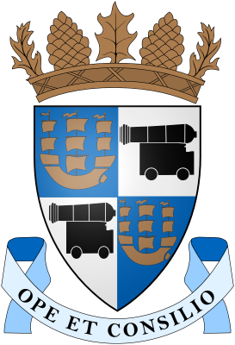

Treasurer’s report for the 27th October 2014
Portobello Community Council Meeting

Balance in bank @ 25 September 2014 | £2674.88

Income from 25 September 2014 to 27 October 2014
-

Expenditure from 25 September 2014 to 27 October 2014
Contribution to Eric Lomax Plaque Event | 100.00
Demarco Event (Print purchase and framing) | 51.99
Dementia Awareness Event donation | 90.00
Flyers for Baileyfield Consultation | 198.62
Distribution of flyers for Baileyfield Consultation | 300.00

Current balance in bank @ 27/10/14 | £2522.89

Balance once all written cheques have cleared: | £1934.27

Forthcoming income or expenditure in next 4 weeks:

